Name : Ansari M.Saeem M.Saleem
Uid : 2019430001
Subject : AAC
Expt no : 6
Aim : Write a program to implement and Analysis Ford-Fulkersion Algorithm

Aim:
Write a program to Implementation and Analysis of Ford-Fulkerson’s algorithm
Objectives:
- Initialization and insertion of element in graph using C/Java/python programming language.
- Finding Max Flow in a graph.
Methodology:
Given a graph which represents a flow network where every edge has a capacity. Also given two vertices source ‘s’ and sink ‘t’ in the graph, find the maximum possible flow from s to t with following constraints:
- Flow on an edge doesn’t exceed the given capacity of the edge.
- Incoming flow is equal to outgoing flow for every vertex except s and t.

Time Complexity:
When the capacities are finite integers, the runtime complexity of Ford–Fulkerson’s algorithm is bounded by O(Ef) where E is the number of edges in the graph and f is the maximum flow in the graph.
Reference Paper:
Paper Title : Application of Ford-Fulkerson Algorithm to Maximum Flow in Water Distribution Pipeline Network.
Authors: Myint Than Kyi*, Lin Lin Naing**
Publication : International Journal of Scientific and Research Publications, Volume 8, Issue 12, December 2018
Overview : In this paper Ford-Fulkerson algorithm in graph theory is used to calculate the maximum flow in water distribution pipeline network of Pyigyitagon Township in Mandalay, Myanmar from single-source to single-sink.

Geographical view:

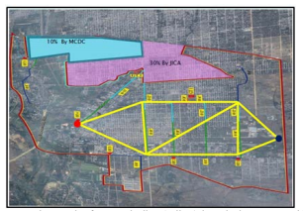

Graph: The following graph shows the capacity and current flow in pipeline. Same graph is also use as input in implemented algorithm.
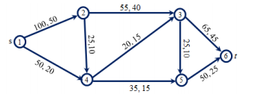

Results:
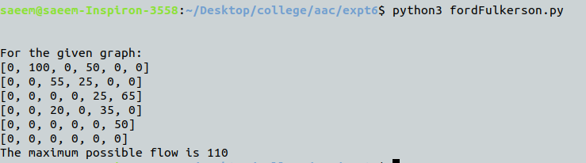
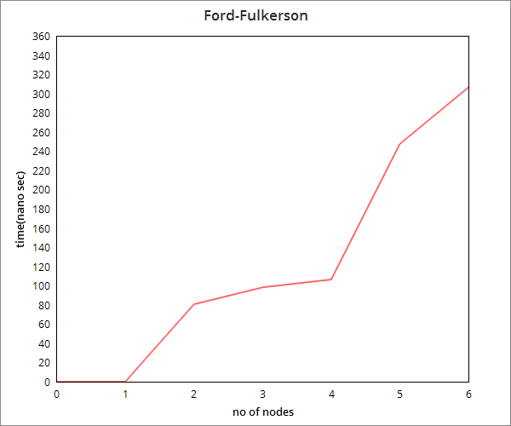

Conclusion:
Here we can conclude that ford-fulkerson’s algorithm is used to calculate maximum flow in a network. Time complexity of this algorithm is directly propotional to the no of nodes in network and max capacity.

